**Estimation and Prediction of Hospitalization and Medical Care Costs**

**1.INTRODUCTION:-**

**PROJECT REPORT**

**Project Title: Estimation and Prediction of Hospitalization and Medical Care Costs.**

**Team ID :** LTVIP2023TMID08578

**Team Size :** 5

**Team Leader :** Somasekhar k

**Team member :** battini saiganesh

**Team member :** shaik mahommadkaif

**Team member :** A Dharanikrishna

**Team member :** Madasu EdigaKarthik

**Faculty mentor:-K.MUNI SANKAR**

* 1. **Overview:-**

Estimation and Prediction of Hospitalization and Medical Care Costs is a data analytics project focused on analyzing and forecasting the expenses associated with hospitalization and medical treatments. The primary goal is to develop models that can accurately estimate the costs incurred by patients and healthcare providers for various medical procedures and hospital stays.

* **Data Collection and Preprocessing :-**

A comprehensive dataset was collected from kaggle Which includes age, sex, region ,charges ,smoker, BMI. The collected data underwent thorough preprocessing to handle missing values, remove inconsistencies, and ensure data quality.

* **Exploratory Data Analysis (EDA) :-**

EDA was conducted to gain a deep understanding of the dataset. Visualizations and summary statistics helped in understanding the characteristics of the data and guided further analysis**.**

* **Creating a Flask web application :-**

For Estimation and Prediction of Hospitalization and Medical Care Costs data involves building an interface where We can input relevant information, and the application will use the predictive model to estimate the medical care costs.

* 1. **Purpose :-**
* The Estimation and Prediction of Hospitalization and Medical Care Costs project plays a vital role in datadriven decision-making, cost optimization, and improving patient care in the healthcare industry. It empowers various stakeholders with actionable insights to make informed choices and enhance the overall efficiency of the healthcare system.
* By undertaking the Estimation and Prediction of Hospitalization and Medical Care Costs project, several significant achievements and benefits can be realized in the healthcare industry and beyond.

**KEY OUTCOMES:**

* **Cost Optimization**
* **Improved Financial Planning**
* **Transparency and Informed Decision-making**
* **Enhanced Patient Care**
* **Tailored Insurance Coverage**

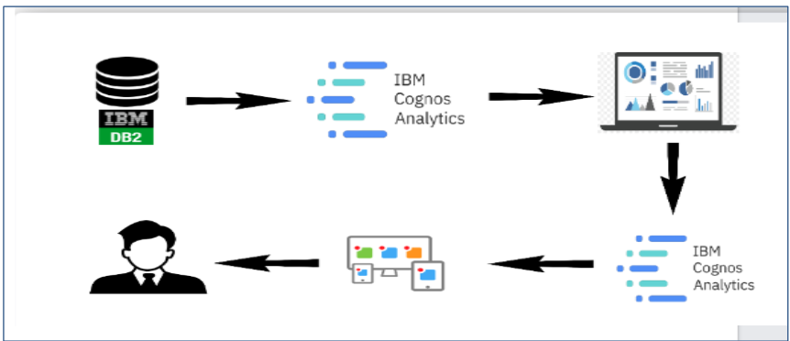

**2.LITERATURE SURVEY**

The prevalence of obesity, which is defined as a body mass index (BMI) greater than 30, has increased dramatically in the United States since the late 1990s.

So much so that recently obesity has been officially recognized as a disease by the American Medical Association, an action that could put more emphasis on the health condition by doctors and insurance companies to minimize its adverse effects. Currently, rates of obesity exceed 30% in most sex and adult age groups, whereas its prevalence among children and adolescents, defined as a BMI of more than the 95th percentile, has reached 17%.

The alarming rates of the high prevalence of obesity have posed a significant public health concern as well as a substantial financial burden on our society because obesity is known to be a risk factor for many chronic diseases, such as type 2 diabetes ,myocardial infarction, cancer ,hypertension, asthma, stroke and other conditions

To understand the economic burden of obesity, several studies have attempted to estimate the attributable costs of obesity, following the burden-of-illness literature on other disease areas. A previous cost-of-illness study estimated that healthcare spending attributable to the rising prevalence of obesity has increased by 27% between 1987 and 2001.

**2.1 Existing Problems**

Solving the Estimation and Prediction of Hospitalization and Medical Care Costs involves a systematic approach that combines data analysis, model development and evaluation.

**2.2 Proposed Solutions**

roposing a solution for the estimation and prediction of hospitalization and medical care costs involves a combination of data-driven techniques, advanced analytics, and domain expertise. Collect comprehensive and diverse data related to hospitalization and medical care costs from various sources, including electronic health records, insurance claims, and administrative databases. The success of the proposed solution depends on the availability of quality data, collaboration with healthcare experts, and a commitment to continuous improvement based on real-world feedback. Healthcare cost estimation and prediction are complex tasks, and a multidisciplinary approach is crucial for achieving accurate and reliable results.

**3.THEORITICAL ANALYSIS**

**3.1 SOFTWARE OR HARDWARE DESIGNING**

**Software Requirements:**

* IBM cognos analytics Tool
* Flask
* Integrated Development Environment (IDE)- Spyder

**Hardware Requirements:**

* + Processor
  + Memory (RAM)
  + Storage
  + Graphics Processing Unit (GPU)
  + Internet Connection

**4.RESULT**

**DASHBOARD**

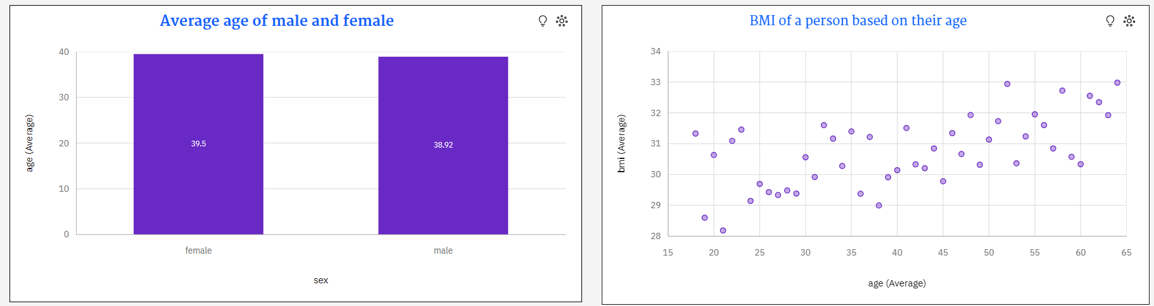

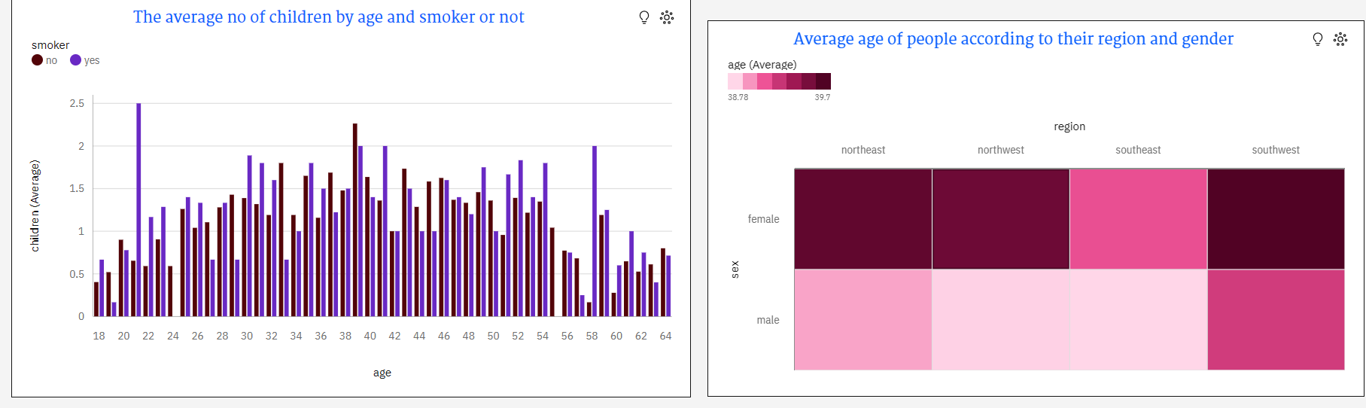

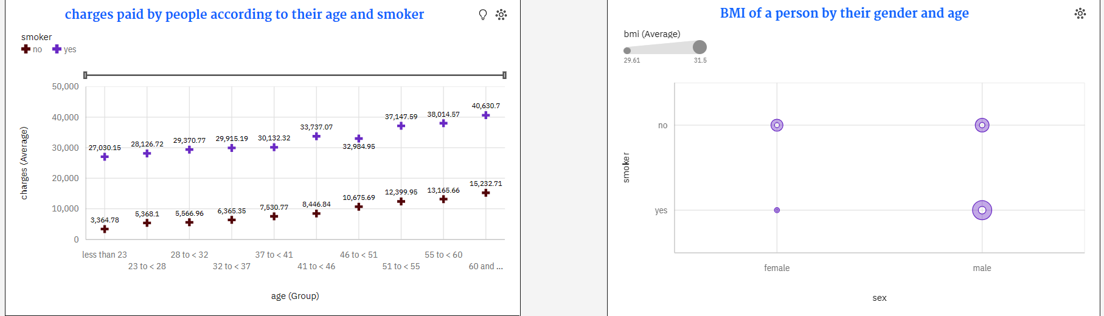

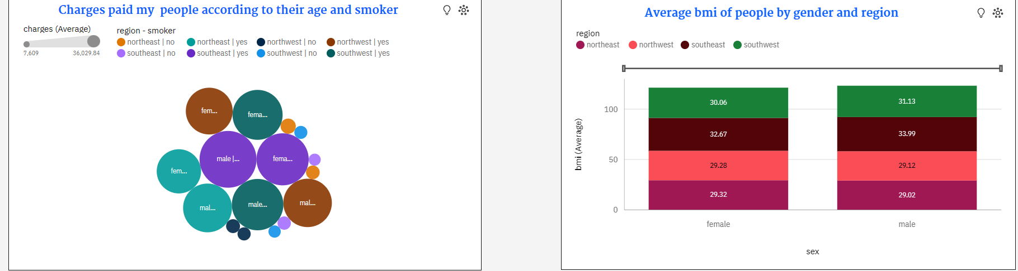

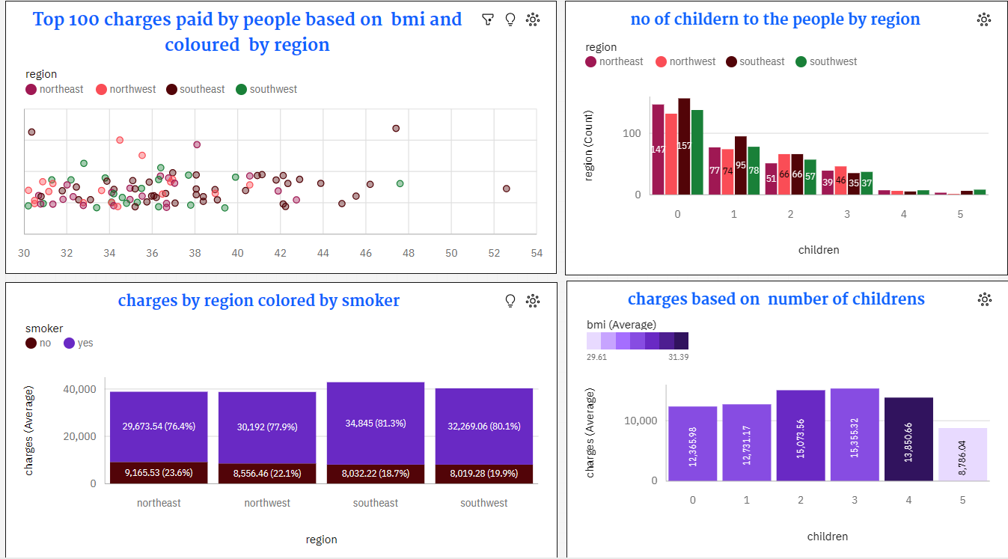

**STORY**

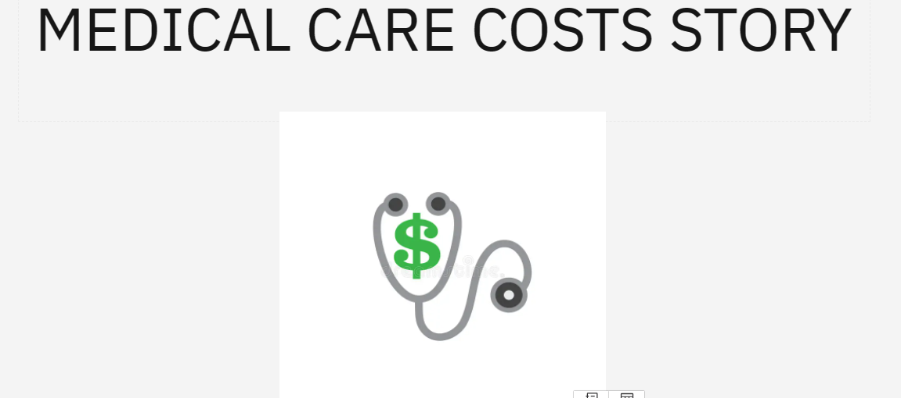

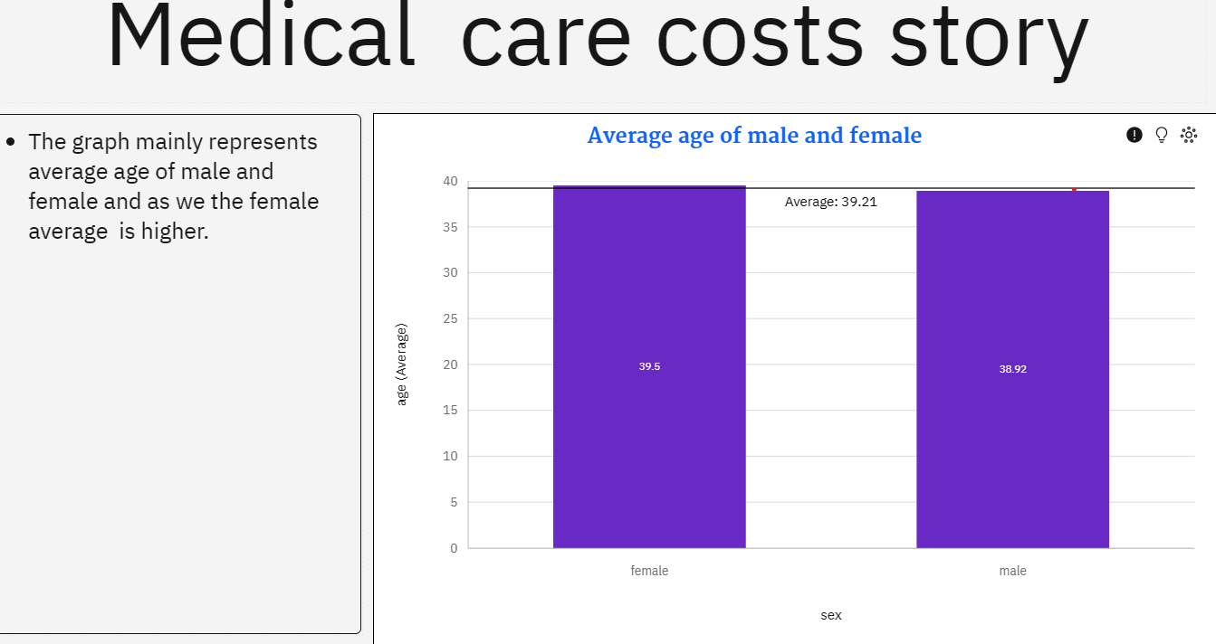

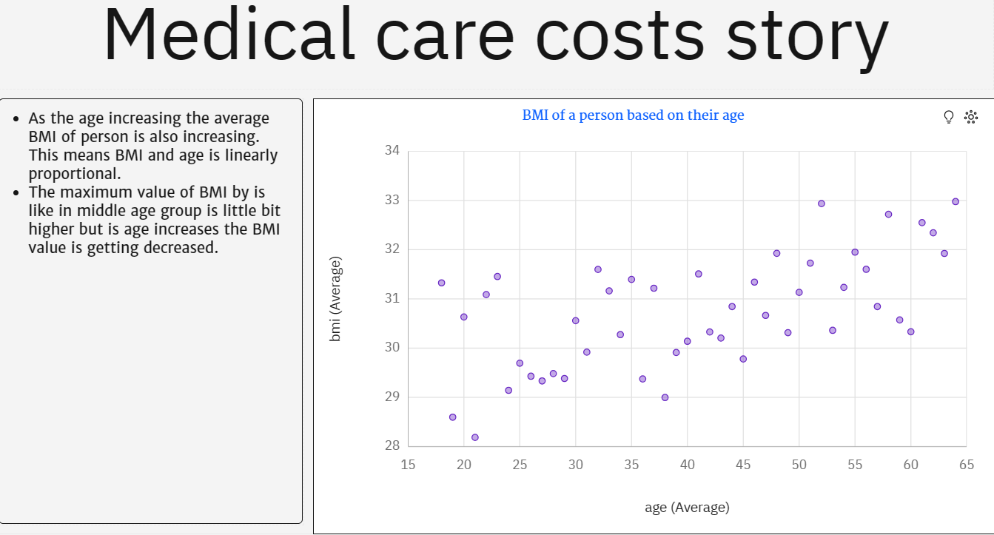

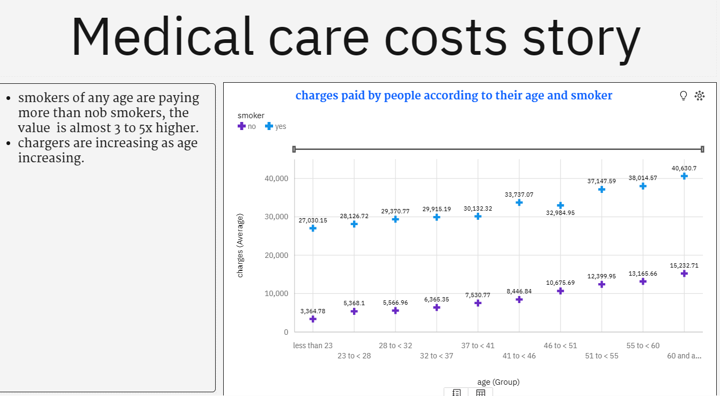

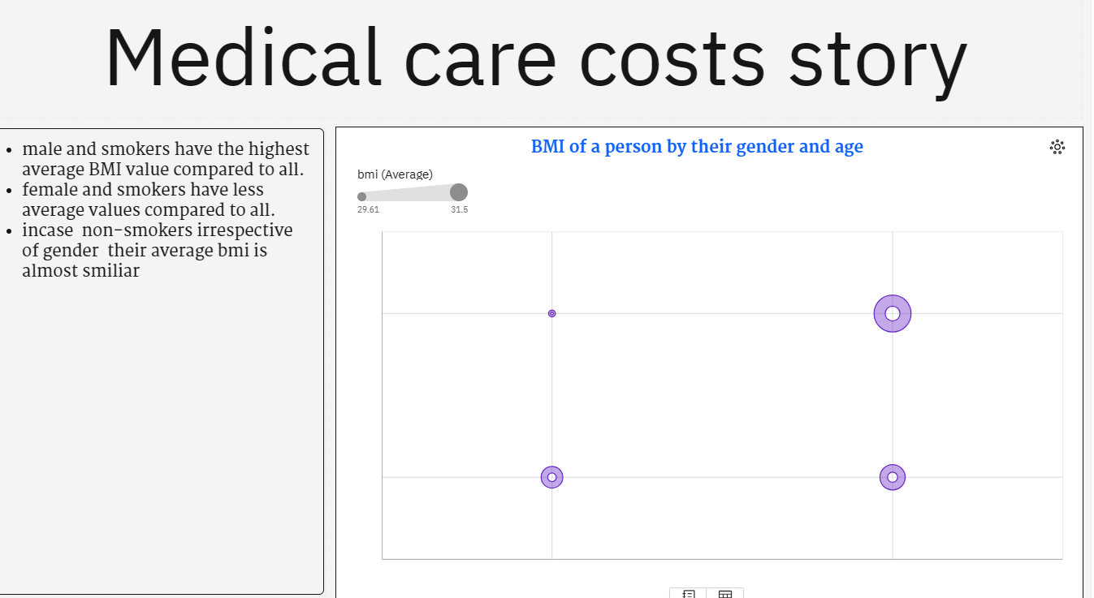

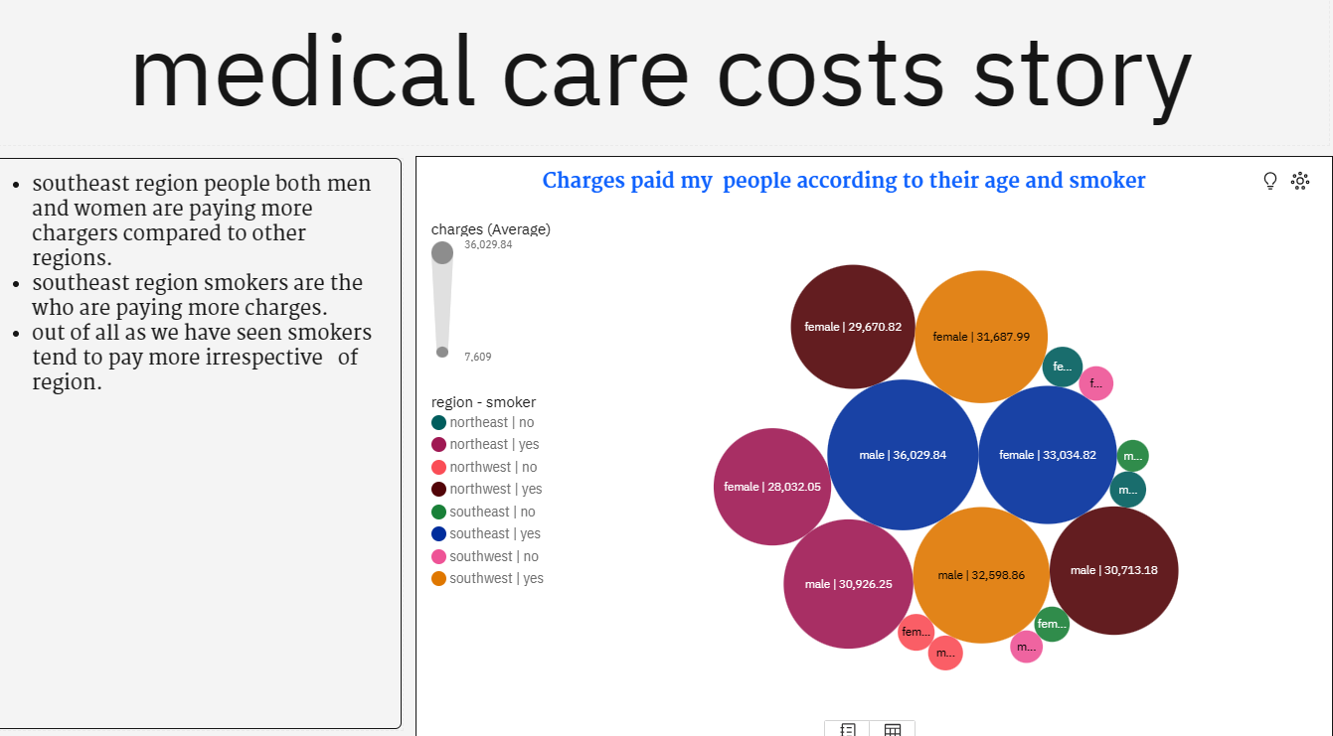



**REPORT**

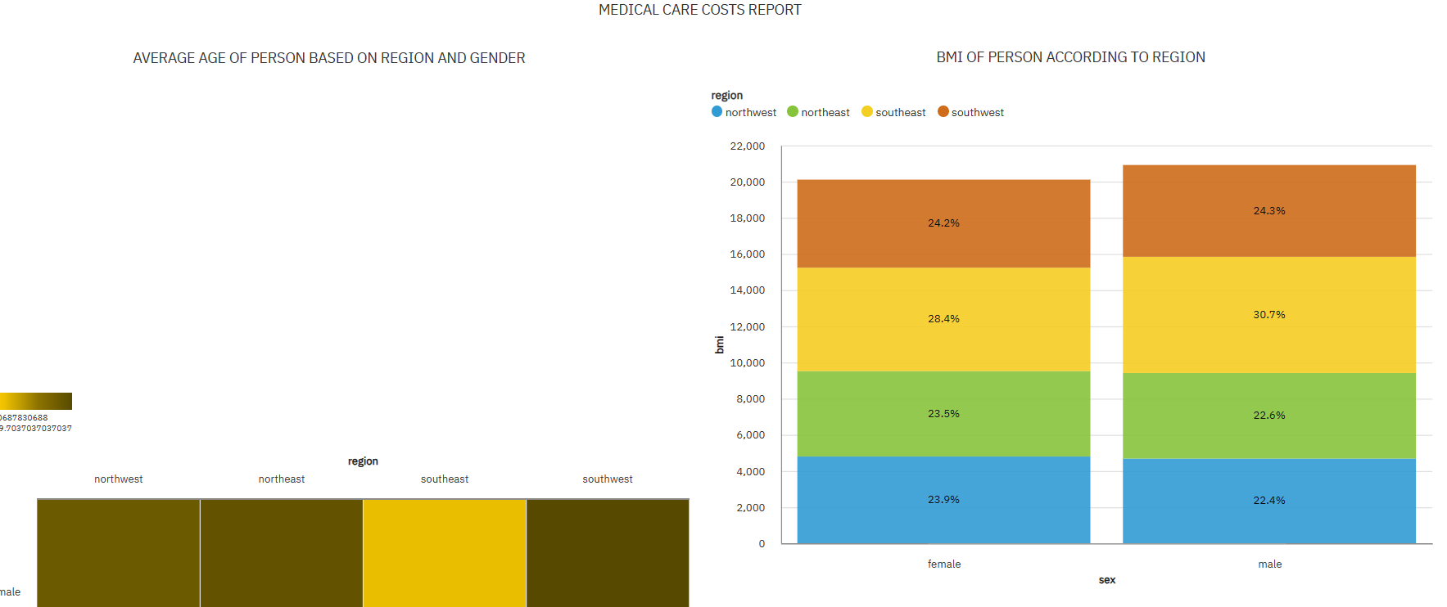

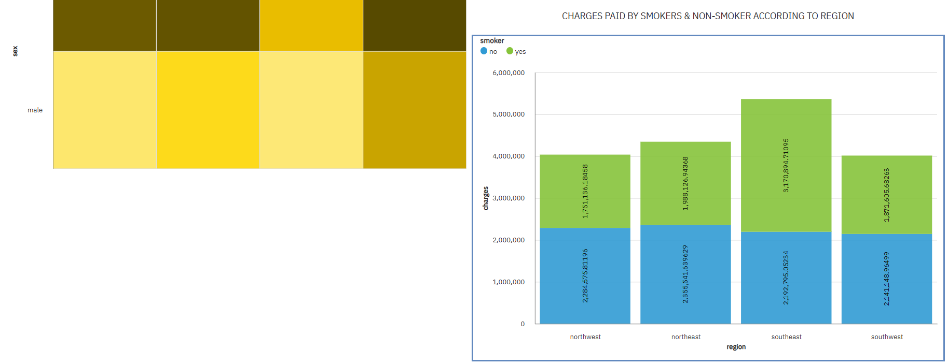

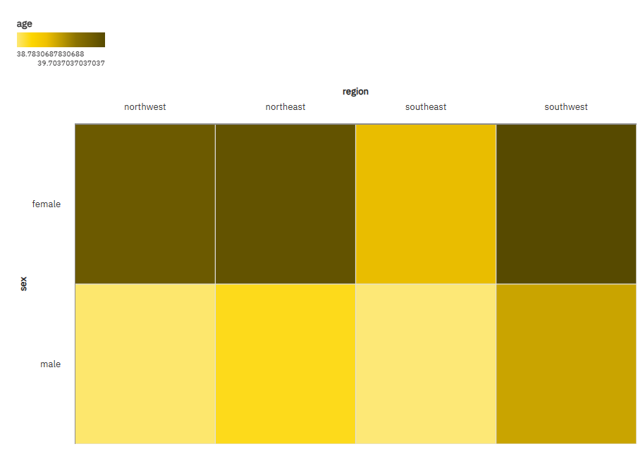

**WEB INTEGRATION**

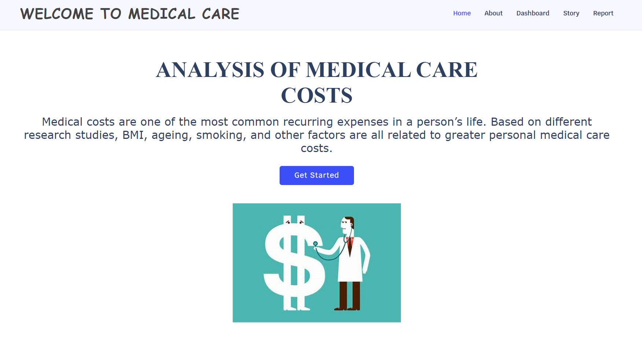

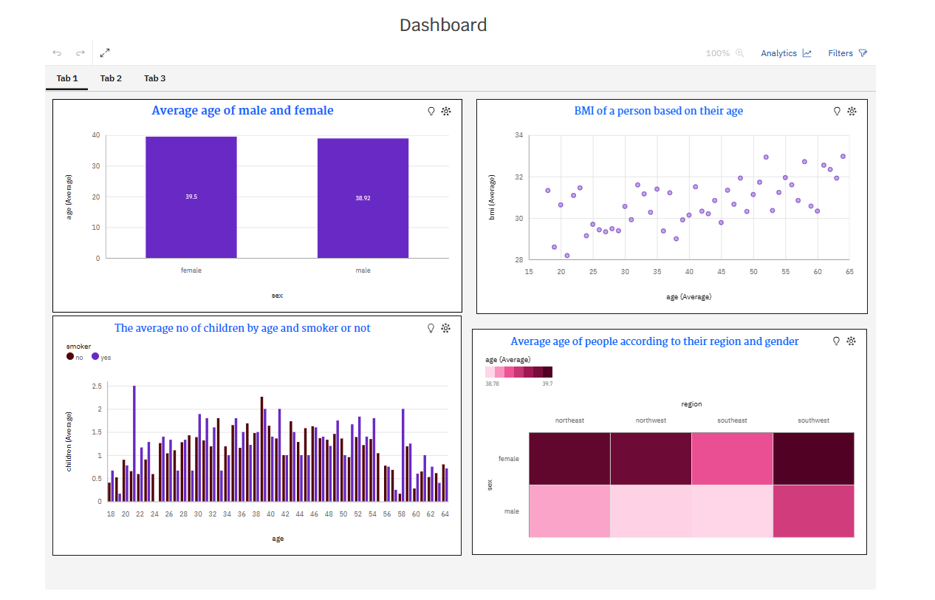

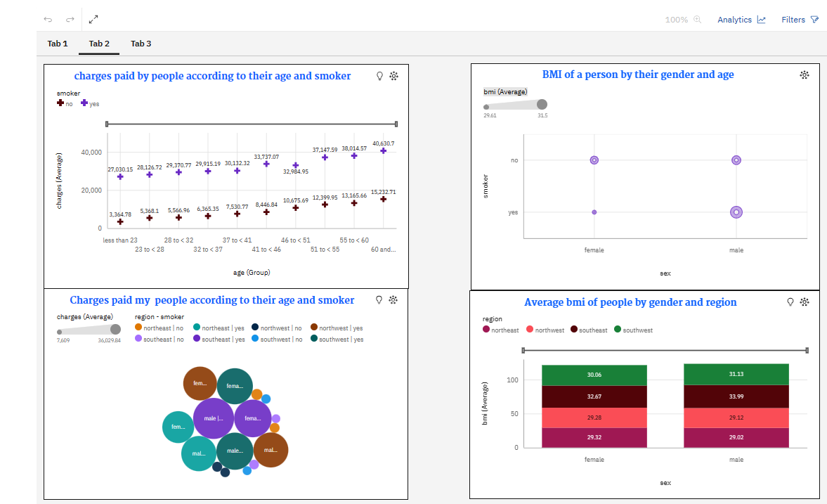

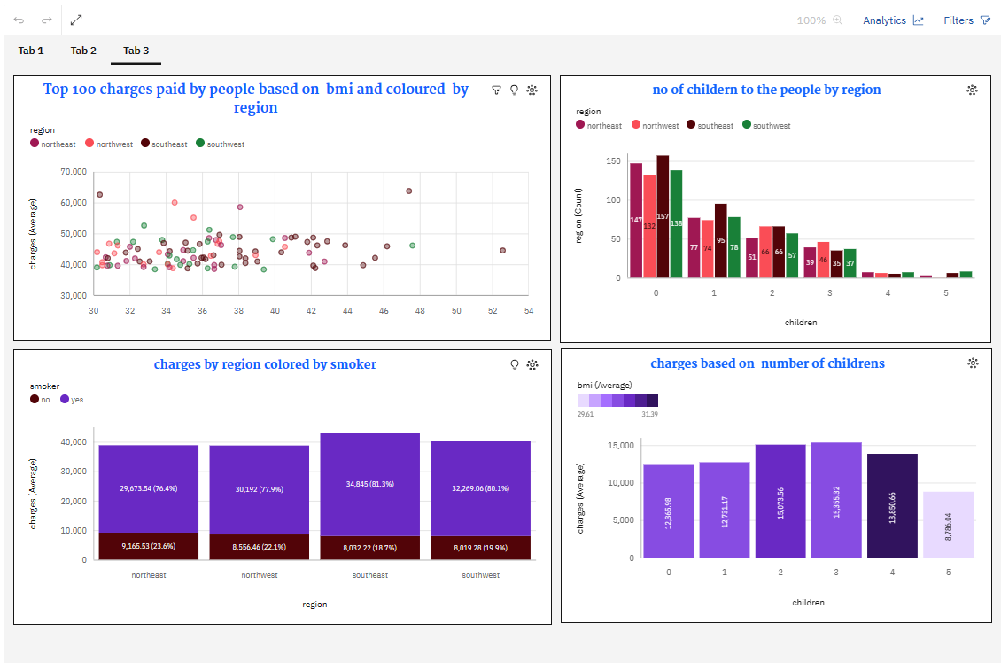

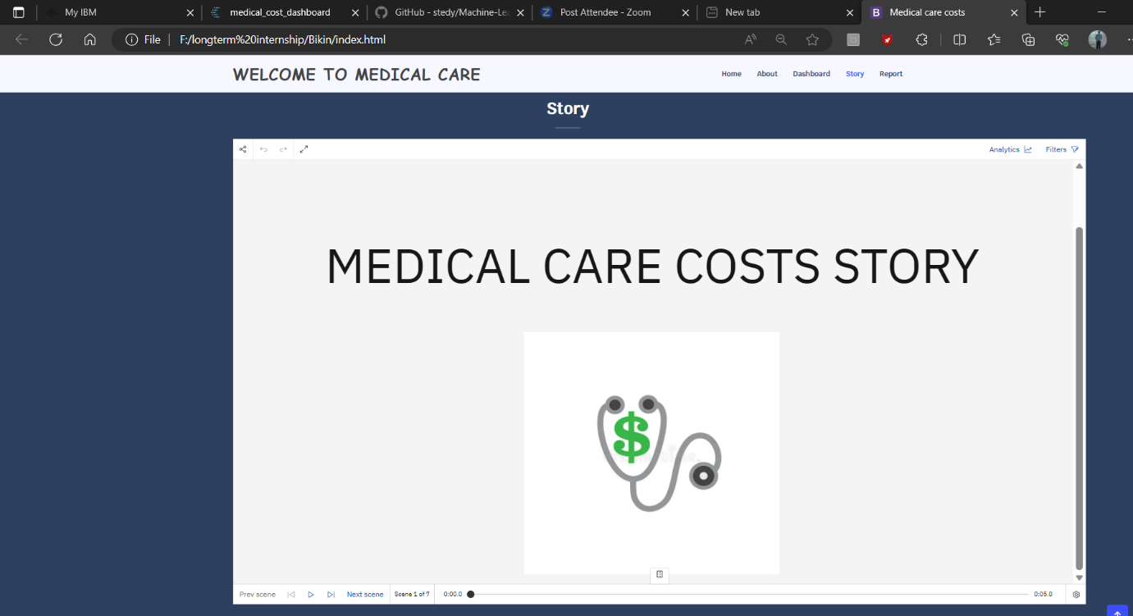













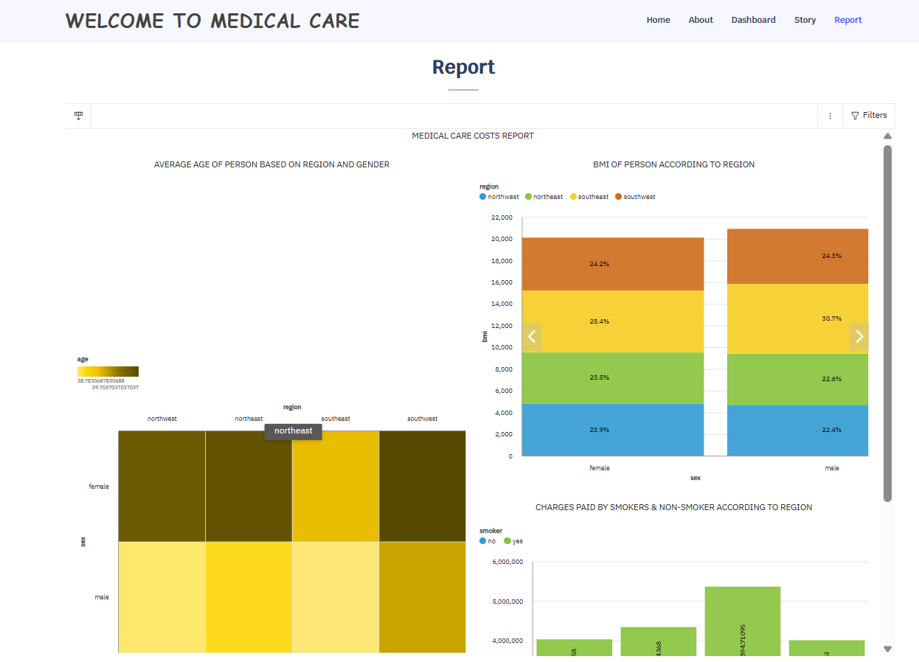

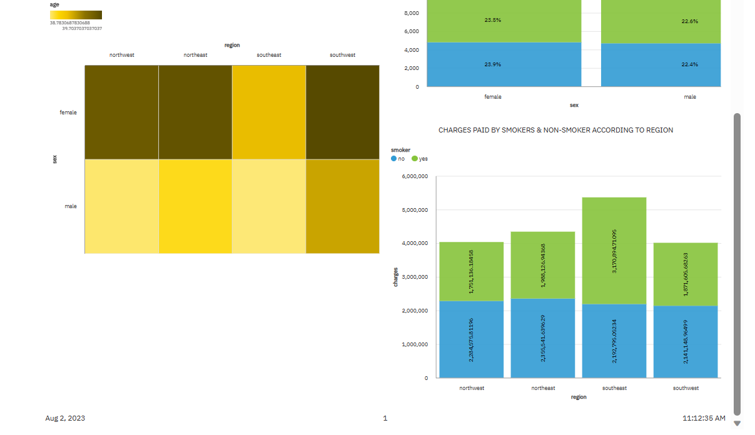

**5.ADVANTAGES & DISADVANTAGES**

**Advantages**

* Cost Optimization
* Informed Decision-making
* Improved Patient Care
* Tailored Insurance Coverage
* Fraud Detection
* Research and Policy Development

**DISADVANTAGES**

* Data Privacy Concerns
* Data Quality
* Model Complexity
* Limited Predictability
* Ethical Considerations
* Overemphasis on Costs

**6.APPLICATIONS**

The Estimation and Prediction of Hospitalization and Medical Care Costs project has several valuable applications in the healthcare industry and beyond.

* Healthcare Cost Management
* Financial Planning
* Insurance Pricing and Coverage
* Resource Allocation
* Treatment Decision Support
* Patient Cost Transparency
* Policy Development
* Fraud Detection
* Benchmarking and Performance
* Research and Public Health
* Cost-Effective Healthcare Programs
* Long-Term Cost Control

**7.CONCLUSION:**

In conclusion, the Estimation and Prediction of Hospitalization and Medical Care Costs project holds significant value and potential for the healthcare industry. By leveraging data analytics, exploratory data analysis ,the project aims to achieve several important outcomes.

Lastly we have to create the web integration in the python folder. Download the bikin file and run the index.html in spyder.

**8.FUTURE SCOPE:**

The future scope of the Estimation and Prediction of Hospitalization and Medical Care Costs project is vast.

And holds great potential in transforming the healthcare industry. Overall, the future scope of the Estimation and Prediction of Hospitalization and Medical Care Costs project is dynamic and transformative. As technology continues to evolve and data-driven decision-making becomes increasingly prevalent, the project's applications have the potential to revolutionize healthcare cost management, resource allocation, and patient care on a global scale.